PARTNERSHIP / COLLABORATION

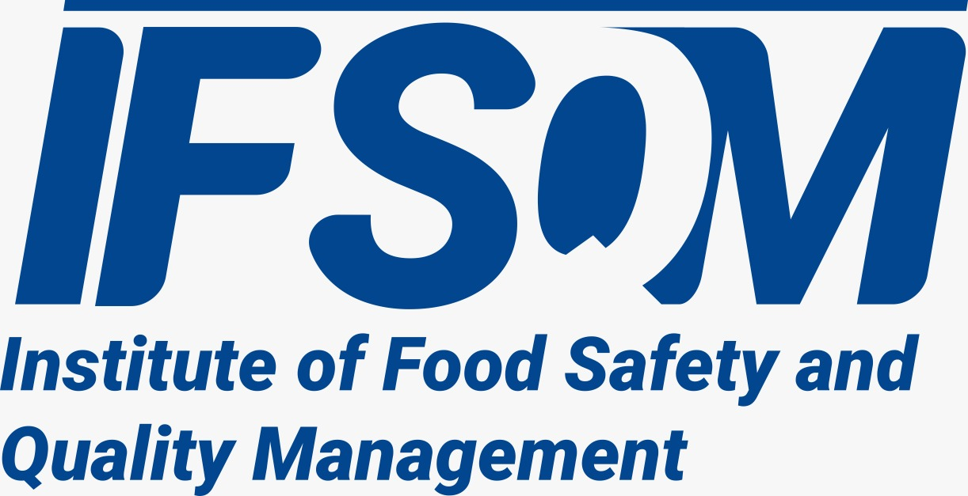
The Institute of Food Safety and Quality Management (IFSQM) operates in partnership with the Institute of Nutritional Therapy Management (INTM) to deliver quality training, certification, and professional development in food safety, hygiene, and nutrition.
This collaboration is committed to advancing professional standards, promoting best practices, and equipping individuals with the knowledge and practical skills required to ensure safe food handling, prevent contamination, and support public health across the food and health sectors

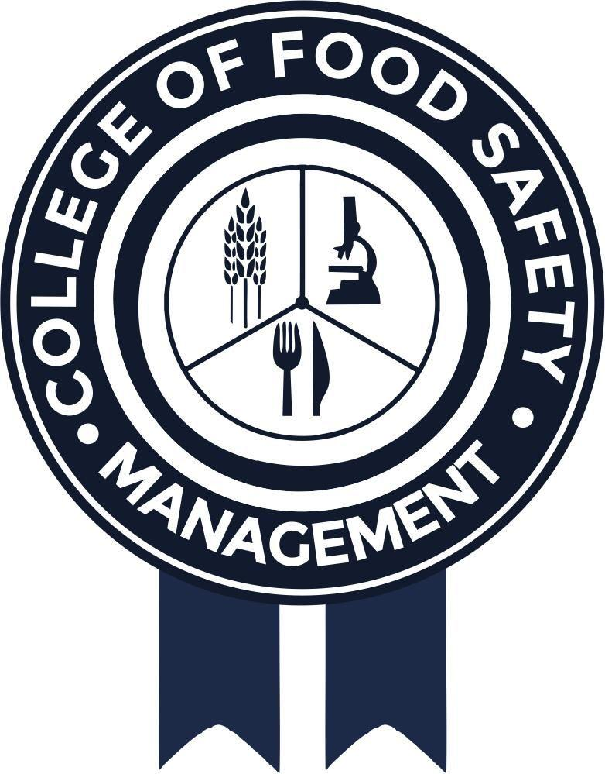
The College of Food Safety Management is a professional training institution focused on promoting food safety, hygiene practices, and quality standards across the food industry.
In partnership with the Institute of Nutritional Therapy Management, the College provides structured training and certification programs that equip individuals with the knowledge and skills needed to ensure safe food handling, prevent contamination, and support public health.

